“Borrow a Machzor”
Our High Holy Day Prayer Book Program
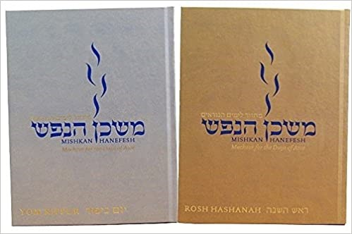
Temple Sinai’s Rabbis and Music Prayer Ritual Committee aspire to provide our worshippers with meaningful and engaging High Holy Day worship. This year, rather than screen-sharing the High Holy Day machzor (prayer book) on Zoom, we have planned opportunities to use the prayer books in your home.

We encourage those congregants who will participate in High Holy Day services online to obtain their own set or to borrow our prayer books.

There are many different ways you can obtain these books:

- You can purchase a digital edition of the prayer books from Amazon for $9.99/ each book (2 volumes). The digital edition does not require a Kindle device, only the Kindle app.

- You can purchase your own set (regular or large-print): from Kolbo (617-731-8743), Israel Book Shop ((617) 566-7113), CCAR Press ($46 plus shipping) https://www.ccarpress.org/search.asp?searchString=hanefesh, or Amazon ($46 plus shipping).

- Grab and Go: Pick up and return your set/s in the lobby of the school building from 9:00am-4:30pm Monday-Thursday or Friday 9:00am-2:00pm between September 7-October 4. We ask that you please return your books by October 7.

- Drive-thru: Pick up your set/s without leaving your car at a drive-thru distribution event on Sunday morning, September 18 from 9:30 am-11:30am. Sign up here by Friday, September 16: https://docs.google.com/spreadsheets/d/1_hhNeUaER9ll4sXXje9LSFbatn4DZkNWXXw8o2EikoM/edit?usp=sharing

- For congregants unable to physically come to the Temple, we will provide home delivery and pick up on request. Sign up here by Friday, September 16: https://docs.google.com/spreadsheets/d/13jHEtzujwmIClOv4qy52SeOJUkawE7PYgU-8XFyNi98/edit?usp=sharing

We look forward to observing the High Holy Days with you this fall. Shanah Tovah!

Temple Sinai 50 Sewall Avenue Brookline MA 02446 (617) 277-5888 www.SinaiBrookline.org

