|  |
| --- |
|  |

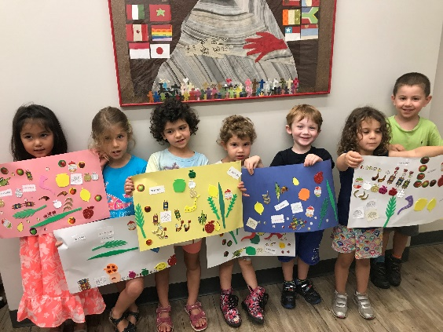

**FREE & FUN Jewish program for 3- & 4-Year-Olds**

**Once a month on Sunday mornings:**

**10:00 AM – 12:00 PM**

**at Temple Sinai, Brookline**

*Early drop-off & late pick-up available*

Come explore Judaism! This fun, interactive Jewish drop-off program for 3- & 4-year olds introduces children to Jewish holidays and practice through arts & crafts, song, stories and games. It’s a great way to introduce your child to the joy of Jewish learning!

K’tonton is taught by Karen Halfon, a teacher with over 20 years of experience with teaching young children.

***Free & open to the entire community. All are welcome!***

**2022-23 K’tonton Dates:**

**September 18 February 12**

**October 16 March 12**

**November 13 April 2**

**December 11 May 7**

**January 8**

Temple Sinai 50 Sewall Ave Brookline, MA 02446 [www.sinaibrookline.org](http://www.sinaibrookline.org) - 617.277.5888