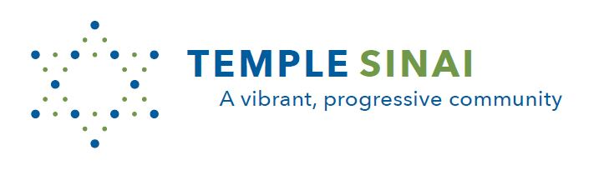
Families with Young Children! Please join us for…
Tot Shabbat
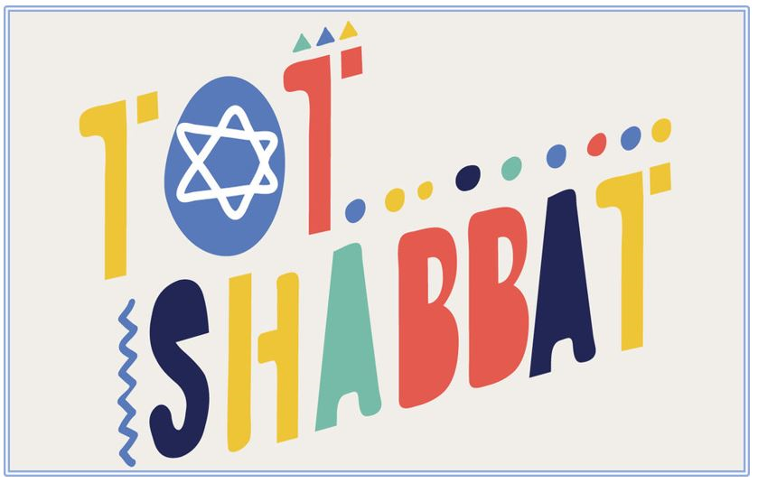

A joyful Shabbat celebration for families with children ages 0-7

at Temple Sinai in Brookline

with Sam Tygiel
Temple Sinai’s Rabbinic Intern

Sing Shabbat songs, hear a story, learn prayers
& play together!

Once a month - Saturday mornings, 9:30 – 10:00 a.m.

September 17 (Weintraub Rm)
October 8 (Weintraub Room)
November 12 (Weintraub Rm)
December 17 (Weintraub Rm)
January 21 (Sanctuary)

February 11 (Weintraub Room)
March 18 (Weintraub Room)
April 22 (Sanctuary)
May 20 (Sanctuary)
June 10 (Sanctuary)

Free and open to the entire community. All are welcome!

Temple Sinai 50 Sewall Ave Brookline MA 02446 www.sinaibrookline.org 617.277.5888

